### VISVESWARAYA TECHNOLOGICAL UNIVERSITY

**JNANA SANGAMA, BELAGAVI -590018**



### AN INTERNSHIP TRAINING REPORT ON~

### IOT COLD CHAIN MONITORING

**SUBMITTED FOR THE FOURTH SEMESTER OF AY:2022-2023**

**BY**

 **Abhinav**

**Usn- 1NT21EC185**

**(Duration: From 07-07-2023 to 06-08-2023)**

Under the Guidance of

**Dr. Viswanatha V**

Assistant Professor

Dept. of Electronics and Communication Engineering





**DEPARTMENT OF ELECTRONICS AND COMMUNICATION ENGINEERING**



### DEPARTMENT OF ELECTRONICS AND COMMUNICATION ENGINEERING

CERTIFICATE

Certified that the Internship work titled “**IOT COLD CHAIN MONITORING”** is carried out by **ABHINAV DUBEY (1NT21EC185),** bonafide student of Nitte Meenakshi Institute of Technology in partial fulfillment of Internship Training in the department of Electronics and Communication Engineering of Visvesvaraya Technological University, Belagavi during the Academic Year 2022-2023. The Internship report has been approved as it satisfies the academic requirement in respect of the Internship work prescribed as per the autonomous scheme of Nitte Meenakshi Institute of Technology for the said course.

|  |  |  |
| --- | --- | --- |
| **Signature of the Guide**  **Dr. Viswanatha V** | **Signature of the HOD**  **Dr. Ramachandra A C** | **Signature of the Principal**  **Dr. H C Nagaraj** |
| **Assistant Professor** | **HOD** | **Principal** |
| **Dept. Of ECE, NMIT** | **Dept Of ECE, NIMT** | **NMIT** |

# INDEX

Contents Page NO.

1. Introduction i
2. Acknowledgement ii
3. Abstract iii
4. Introduction to IoT 1
5. Working ESP32 SIM800L 2
6. ESP 32 4
7. Description 8
8. Project Overview 10
9. Cold Chain Monitoring 12

10. Data result over Blynk IoT Cloud 17

11. Conclusion 19

12. Reference 21

## INTRODUCTION

Technology's tremendous development has made cultivation more prevalent and critical. Distinctive devices and methods are accessible for improvement in cultivation. According to the UN Food and Agriculture Organization survey, the goal is to encourage the production rate of food substances for the developing populace of the Earth. The world should create 70% more sustenance in 2050 than it did in 2016. Keeping this in mind, cultivators and horticultural industries are using the Internet of Things to investigate and enhance production capacities. Internet of Things (IoT) is very much important in expanding productivity and getting colossal worldwide business. IoT is a system of interconnected networks and budgets that can exchange information effectively without human association.

Nowadays numerous agricultural industries embrace IoT innovation to brilliant cultivating for upgrade proficiency, efficiency, worldwide business, and other futures, for example, least human mediation, time and cost, and so on. This innovation ensures that sensors are getting a little more sophisticated and financial. Smart cultivation is successful because networks are used worldwide. Concentrating more on innovation in the agricultural system, smart farming is the major solution to the problems that industries facing today. With the possible utilization of IoT devices and smartphones, farmers can get the required information and can monitor their agricultural sector.

The Internet of things (IoT) is the most proficient essential procedure for the improvement of solutions for those issues. IoT developed from various building blocks that incorporate bunches of sensors, software, organized parts, and some other electronic budgets. Likewise, it makes information more efficient.

IoT merges the ideas “Internet” and “Thing” and can in this manner semantically be defined as “a worldwide system of interconnected objects uniquely addressable, based on standard communication protocols”.

When we refer to “Things”, they consist of devices and everyday objects from small things (sensors, watches) to big things (robots, buildings, vehicles). All of these contain devices that interact with users by generating and retrieving information from the environment.

## ACKNOWLEDGEMENT

The completion of any work is a showcase of the constant dedication and co-operation of many people who lent their hands, which went unseen.

I am grateful to Institution and Management, **NITTE MEENAKSHI INSTITUTE OF TECHNOLOGY** for its ideals and inspiration for having provided with the facilities, which has made this work a success. NMIT was started by Vinaya Hegde, son of founder

of [NMAMIT](http://www.nitte.ac.in/), late [Justice K. S. Hegde](https://en.wikipedia.org/wiki/Justice_K._S._Hegde) in 2001 after the success of Nitte Mahalinga Adyanathaya Memorial Institute of Technology (NMAMIT) at Nitte.

I would like to thank our beloved Principal Dr. H C Nagaraj, NMIT for his kind disposition in completing this internship successfully.

I express our heart full gratitude to Dr. Ramachandra A C, HOD, Dept. of Electronics and Communication & Engineering, NMIT, for guiding us with valuable advice, and support.

I extend my gratitude to our guide Prof. Dr. Vishwanatha V, Assistant Professor, Dept of Electronics and Communication Engineering, NMIT, for all their prolific support, teaching, guidance, and valuable suggestions at all stages of this complete process.

I also thank all professors and the entire Dept of Electronics and Communication Engineering, for their co-operation and suggestions. The report would be incomplete if we do not thank our parents and friends for their continuous encouragement and moral support.

## ABSTRACT

The Internet of Things (IoT) has revolutionized various industries, and one of its pivotal applications is in cold chain management. This abstract provides an overview of IoT-enabled cold chain monitoring, which plays a critical role in preserving the quality and safety of temperature-sensitive products during storage and transportation.Cold chain monitoring involves the continuous tracking and management of temperature-sensitive goods, such as perishable food items, pharmaceuticals, vaccines, and chemicals, throughout their entire supply chain journey. The primary objective is to maintain the required temperature conditions, preventing temperature excursions that could lead to product spoilage, reduced efficacy, or even harm to consumers.IoT technologies have brought unprecedented levels of efficiency, accuracy, and transparency to cold chain monitoring. Wireless sensors and devices equipped with temperature, humidity, and other relevant sensors are strategically placed within refrigerated storage units, trucks, shipping containers, and warehouses. These sensors continuously collect data, transmitting it in real-time to a centralized IoT platform via wireless networks.The IoT platform serves as the nerve center, where data is analyzed, monitored, and visualized in real-time. Advanced analytics and machine learning algorithms process this data, enabling stakeholders to make informed decisions swiftly. Notifications and alerts are triggered when temperature deviations occur, allowing immediate corrective actions, such as adjusting thermostat settings, rerouting shipments, or replacing faulty equipment.

# Introduction to IoT

Internet of things (IoT) is the networking of physical objects that contain **electronics embedded** within their architecture to communicate and sense interactions amongst each other or concerning the external environment.

*I*t is a system of interrelated computing devices, mechanical and digital machines, objects, animals, or people that are provided with unique identifiers and **the ability to transfer data over a network without requiring human-to- human or human-to-computer interaction.**

The Internet of Things is a pretty simple concept, **it means taking all the physical places and things in the world and connecting them to the internet**.

In the Internet of Things, all the things that are being connected to the internet can be put into **three categories**:

### Things that collect information and then send it.

1. **Things that receive information and then act on it.**

### Things that do both.

And all three of these have enormous benefits that compound each other.

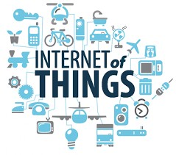

# Working of ESP 32 SIM800L

The TTGO T-Call V1.4 is an ESP32-based development board with integrated wireless and cellular capabilities. It is designed for IoT and communication applications. Here's an overview of how the TTGO T-Call V1.4 works:

**1. ESP32 Microcontroller:**

At the heart of the TTGO T-Call V1.4 is the ESP32 microcontroller. The ESP32 is a powerful and versatile microcontroller that combines a dual-core processor, Wi-Fi, and Bluetooth connectivity, making it suitable for various IoT projects.

**2. GSM/GPRS Module (SIM800L):**

The TTGO T-Call V1.4 board features a SIM800L GSM/GPRS module. This module allows the board to connect to the cellular network, enabling it to send and receive SMS messages, make phone calls, and establish data connections.

**3. ESP32 Development Environment:**

To program and develop applications for the TTGO T-Call V1.4, you can use the Arduino IDE or PlatformIO with the ESP32 board support package. This allows you to write code in C/C++ and upload it to the ESP32 microcontroller.

**4. Peripherals:**

The TTGO T-Call V1.4 board includes various hardware peripherals and interfaces, such as GPIO pins, I2C, SPI, UART, and more. These peripherals allow you to connect sensors, displays, and other external components to your project.

**5. Power Supply:**

The board can be powered via a USB-C connector or an external battery. It has onboard voltage regulation to provide a stable power supply to the ESP32 and other components.

**6. Integrated Antennas:**

The TTGO T-Call V1.4 board typically includes integrated Wi-Fi and Bluetooth antennas, as well as a cellular antenna connector for connecting an external GSM antenna.

**7. Cellular Communication:**

You can use the SIM800L module to establish a cellular data connection (GPRS) to access the internet or send data to remote servers. This is especially useful when you need IoT connectivity in areas without Wi-Fi coverage.

**8. Wireless Connectivity:**

The ESP32 on the board provides Wi-Fi and Bluetooth connectivity. You can connect to Wi-Fi networks for internet access, and you can use Bluetooth for local communication with other devices.

**9. Programming and Control:**

You can program the ESP32 to control both the Wi-Fi/Bluetooth features and the SIM800L module using AT commands. The ESP32 can manage the SIM800L's operation, establish data connections, and send SMS messages as needed.

**10. Applications:**

The TTGO T-Call V1.4 is suitable for a wide range of IoT applications, such as remote monitoring, asset tracking, home automation, and more. Its combination of ESP32 capabilities and cellular connectivity makes it a versatile choice for projects that require both wireless communication and cellular data access.

To work with the TTGO T-Call V1.4, you will typically write code to configure and control the ESP32 and the SIM800L module according to your project's requirements. You can use libraries and examples available in the Arduino IDE or PlatformIO to simplify development. Proper power management and understanding of cellular communication protocols (AT commands) are important when using this board for IoT projects.

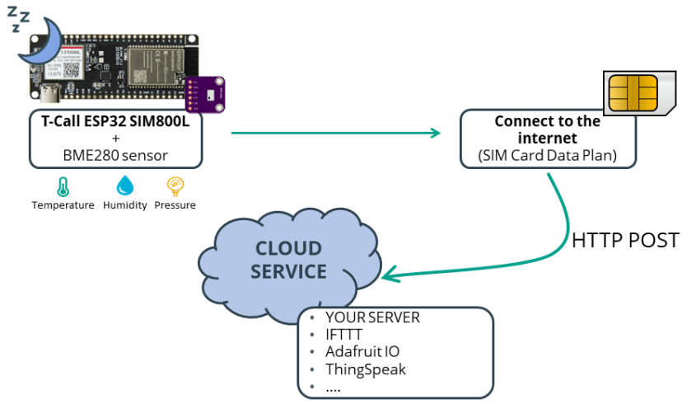

**ESP 32 SIM800L**

### Introduction

### The ESP32 and SIM800L are two different hardware modules often used in IoT (Internet of Things) projects.

### ESP32: The ESP32 is a versatile, low-cost microcontroller and Wi-Fi/Bluetooth module developed by Espressif Systems. It's widely used in IoT projects because of its dual-core processor, ample RAM, built-in Wi-Fi and Bluetooth capabilities, and support for various communication protocols. The ESP32 can be programmed using the Arduino IDE, MicroPython, or the ESP-IDF (Espressif IoT Development Framework), making it a popular choice for IoT applications.

### SIM800L: The SIM800L is a small, compact GSM/GPRS module developed by SIMCom. It is designed for communication over the cellular network, allowing IoT devices to connect to the internet or send and receive SMS messages. The SIM800L module is often used when Wi-Fi or Ethernet connectivity is unavailable or impractical, and cellular communication is preferred.Using ESP32 with SIM800L:Many IoT projects combine the ESP32 with the SIM800L module to enable IoT devices to connect to the internet or send data over the cellular network when Wi-Fi is not available. This combination can be useful in remote monitoring, asset tracking, or other applications where constant internet connectivity is required.Here's a high-level overview of how you can use the ESP32 with the SIM800L.

### Hardware Setup: Connect the ESP32 and SIM800L modules to your development board or custom PCB. This typically involves connecting the necessary power, ground, and communication pins.

### Programming: Write firmware for the ESP32 to control the SIM800L module. You'll need to use AT commands to communicate with the SIM800L over a UART (serial) connection. The ESP32 can send commands to the SIM800L to establish a GPRS data connection, send HTTP requests, or send/receive SMS messages.Data Transmission Once the ESP32 is programmed and the SIM800L is configured, your IoT device can use the cellular network to send data to a remote server, receive commands, or send SMS notifications.Power Management: Since both the ESP32 and SIM800L can consume significant power, power management and optimization are essential, especially if your IoT device is battery-powered.

### ESP 32 SIM800L PIN DIAGRAM:

### 

### https://cdn.shopify.com/s/files/1/0559/1970/6265/files/SIM800L_2048x2048.png?v=1665380425

### Overall, combining the ESP32 with the SIM800L allows you to create IoT devices that are not limited by Wi-Fi coverage, making them suitable for applications where cellular connectivity is essential. However, it's important to note that working with SIM800L may require an understanding of AT commands and cellular networks, which can be more complex compared to using Wi-Fi or other wireless communication methods. An intelligent cold chain system can track and ensure the quality of goods from manufacturer to end-user

### ****TTGO T-Call V1.4 ESP32 Wireless Module****

### https://rarecomponents.com/store/image/data/0-2570-3.jpghttps://rarecomponents.com/store/image/data/0-2570-2.jpg

**Hardware Specifications**

* Chipset:ESPRESSIF-ESP32 240MHz Xtensa® single-/dual-core 32-bit LX6 microprocessor
* FLASH:QSPI flash 4MB / PSRAM 8MB
* SRAM : 520 kB SRAM
* Button：Reset
* USB to TTL：CH340K
* Modular interface：UART、SPI、SDIO、I2C、LED PWM、TV PWM、I2S、IRGPIO、capacitor touch sensor、ADC、DACLNA pre-amplifier
* On-board clock：40MHz crystal oscillator
* Working voltage ：2.7V-3.6V
* Working current :About 70mA
* Sleep current: About 1.1mA
* SIM card:Only supports Nano SIM card
* Working temperature range:-40℃ ~ +85℃
* Size&Weight:78.83mm28.92mm8.06mm(11.77g)

**Power Supply Specifications**

* Power Supply:USB 5V/1A
* Charging current:500mA
* Battery:3.7V lithium battery
* JST Connector:2Pin 1.25mm
* USB:Type-C

**Wi-Fi**

* Standard: FCC/CE-RED/IC/TELEC/KCC/SRRC/NCC(esp32 chip)
* Protocol:802.11 b/g/n(802.11n，speed up to150Mbps)A-MPDU and A-MSDU polymerization，support 0.4μS Protection interval
* Frequency range:2.4GHz~2.5GHz(2400M~2483.5M)
* Transmit Power:22dBm
* Communication distance:300m

**Bluetooth**

* Protocol: meet bluetooth v4.2BR/EDR and BLE standard
* Radio frequency with -97dBm sensitivity NZIF receiver Class-1,Class-2&Class-3 emitter AFH Audio frequency CVSD&SBC audio frequency

**Software specification**

* Wi-Fi Mode:Station/SoftAP/SoftAP+Station/P2P
* Security mechanism:WPA/WPA2/WPA2-Enterprise/WPS
* Encryption Type ：AES/RSA/ECC/SHA
* Firmware upgrade：UART download/OTA（Through network/host to download and write firmware）
* Software Development：Support cloud server development /SDK for user firmware development
* Networking protocol：IPv4、IPv6、SSL、TCP/UDP/HTTP/FTP/MQTT
* User Configuration：AT + Instruction set, cloud server, android/iOSapp
* OS：FreeRTOS

### DESCRIPTION

The ESP32 is a versatile, low-power microcontroller and system-on-chip (SoC) designed by Espressif Systems. It is known for its robust processing power, low energy consumption, and integrated Wi-Fi and Bluetooth capabilities.

**Key Features:**

Dual-core Xtensa LX6 microprocessors.

Integrated Wi-Fi (802.11 b/g/n) and Bluetooth (Bluetooth Classic and BLE) connectivity.

A wide range of GPIO pins for various digital and analog I/O tasks.

On-chip flash memory and RAM for program storage and execution.

Support for multiple communication protocols, including SPI, I2C, UART, and more.

Extensive development support, including the Arduino IDE, MicroPython, and Espressif's own ESP-IDF.

**Use Cases:** The ESP32 is commonly used in IoT projects for tasks such as sensor data collection, wireless communication, home automation, robotics, and more. Its dual-core architecture makes it suitable for multitasking applications.

**2. SIM800L:**

**Description:** The SIM800L is a compact GSM/GPRS module developed by SIMCom. It is primarily designed for cellular communication and is often used to provide IoT devices with internet access or SMS functionality over the cellular network.

**Key Features:**

Quad-band GSM/GPRS support (850/900/1800/1900 MHz) for global compatibility.

UART interface for communication with a microcontroller or host device.

SIM card slot for a GSM SIM card, which is required for network access.

Capability to send and receive SMS messages.

Data transmission features for connecting to the internet using GPRS.

AT command set for controlling and configuring the module.

External antenna connector for improved signal reception.

**Use Cases:** The SIM800L is commonly used in IoT applications where Wi-Fi or Ethernet connectivity is not available or practical. It can be employed in asset tracking, remote monitoring, and other scenarios where cellular communication is necessary.

**Using ESP32 with SIM800L:** Combining the ESP32 with the SIM800L allows you to create IoT devices that benefit from the ESP32's processing capabilities and the SIM800L's cellular connectivity. This combination is particularly useful when your IoT device needs to send data over the cellular network or communicate via SMS in areas without Wi-Fi coverage.

To use the ESP32 with the SIM800L, you typically set up a UART connection between the two modules and use AT commands to control the SIM800L's functionality from the ESP32. This enables your ESP32-based device to establish a cellular data connection, send and receive SMS messages, and transmit data to remote servers over the cellular network. Proper power management and optimization are crucial, especially if your IoT device is battery-powered.

8

Keep in mind that the specific wiring and AT command sequences may vary depending on the manufacturer of your ESP32 and SIM800L modules, so it's important to refer to their respective datasheets and documentation for detailed instructions.

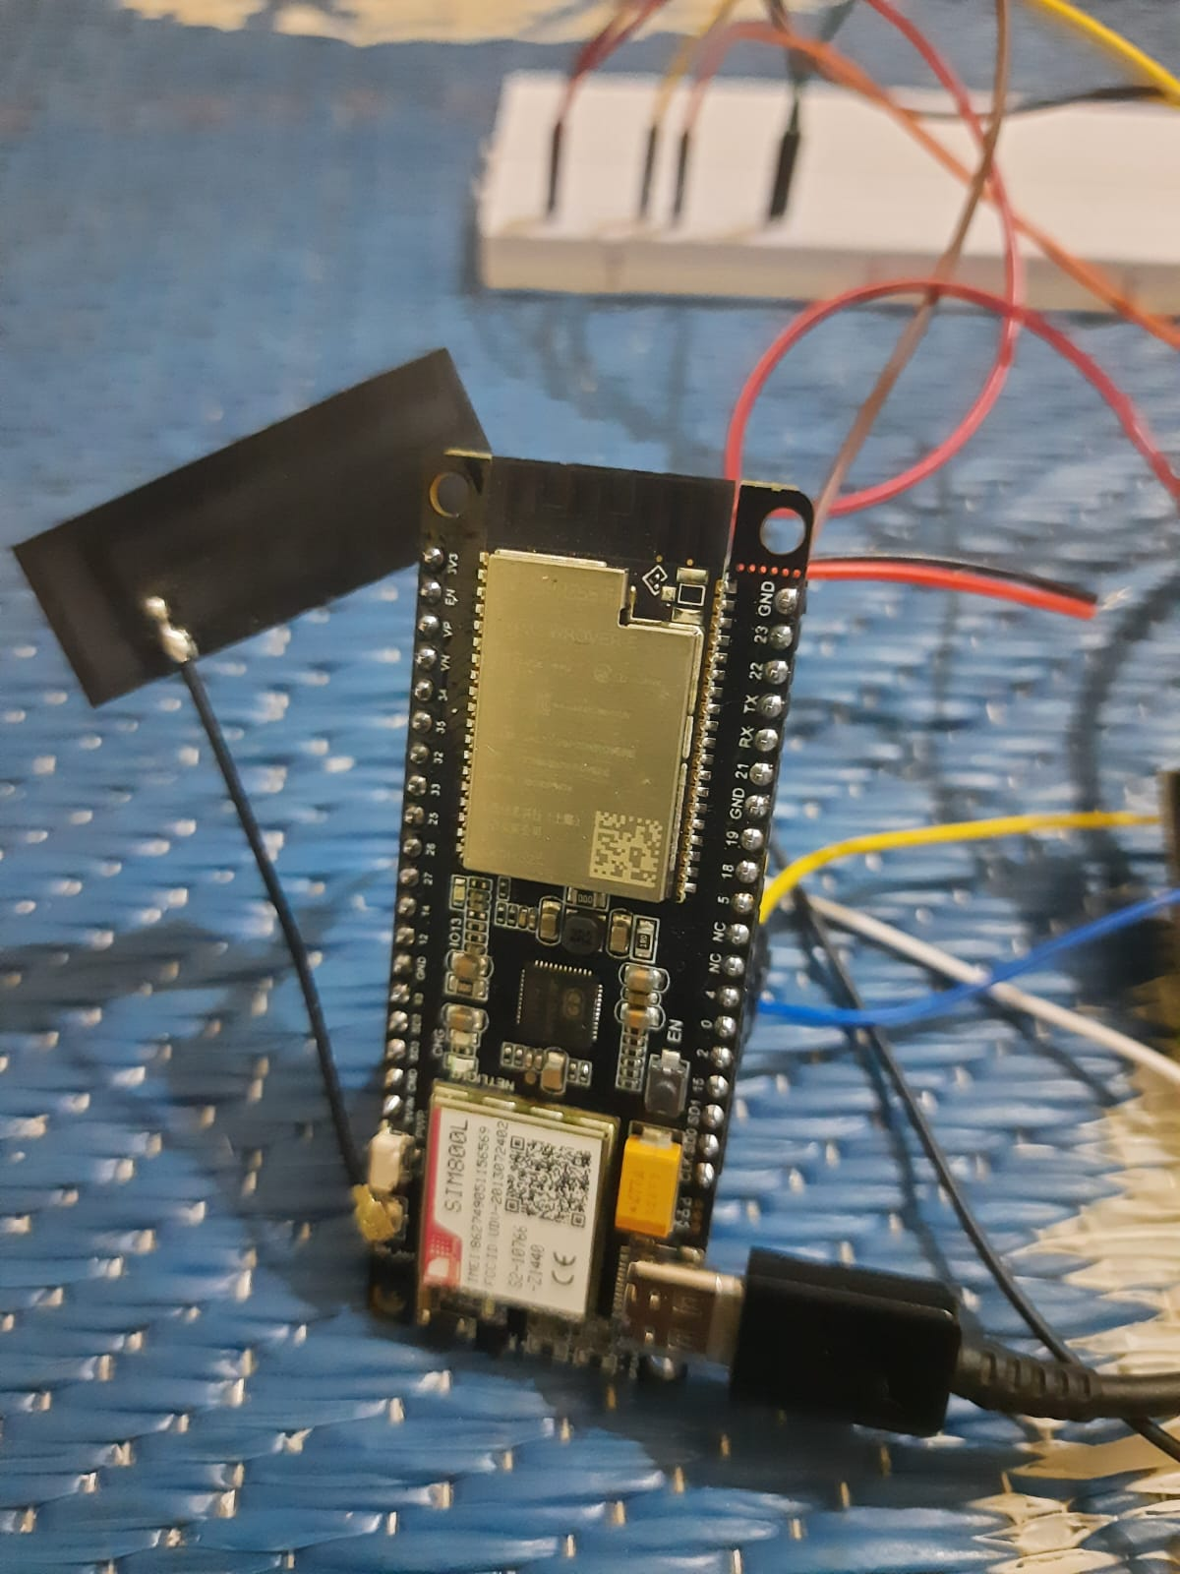

**PROJECT OVERVIEW**

The IoT Cold Chain Monitoring System is designed to monitor and maintain the temperature and humidity levels of temperature-sensitive goods during their entire journey within the supply chain. This system ensures the integrity and safety of these products by providing real-time data, alerts, and reporting capabilities.

Components and Equipment:

1. ESP32 or ESP8266 Development Board: This serves as the core controller for data collection and communication.
2. Temperature and Humidity Sensors: Use sensors like DHT22, DHT11, or specialized industrial sensors to measure environmental conditions.
3. GSM/GPRS Module (e.g., SIM800L): For cellular connectivity when Wi-Fi is unavailable.
4. IoT Platform: Cloud-based platforms like AWS IoT, Azure IoT, or Google Cloud IoT to manage data.
5. Power Supply: Depending on your setup, consider batteries or a reliable power source.

Project Implementation:

1. Sensor Setup:
   * Connect the temperature and humidity sensors to the ESP32 board.
2. Data Collection:
   * Configure the ESP32 to read data from the sensors at regular intervals.
   * Store the data locally on the ESP32 or transmit it to the IoT platform via Wi-Fi or cellular connectivity.
3. Connectivity:
   * Use Wi-Fi whenever available for cost-effective data transmission. If Wi-Fi is not available, the system should automatically switch to the GSM/GPRS module to ensure continuous monitoring.
4. Data Transmission:
   * Send the collected data to the IoT platform securely using MQTT, HTTP, or another appropriate protocol.
5. IoT Platform Integration:
   * Set up the IoT platform to receive, store, and analyze data.
   * Implement alerting mechanisms to notify stakeholders when temperature deviations occur.
6. Data Visualization:
   * Create a user-friendly dashboard or mobile app that displays real-time temperature and humidity data, historical trends, and alerts.
7. Alerting System:
   * Implement real-time alerts and notifications through email, SMS, or push notifications when temperature or humidity deviates from specified thresholds.
8. Data Logging:
   * Store historical data in a secure and scalable manner for compliance and analysis purposes.
9. Remote Control:

10

* + Optionally, provide remote control capabilities to adjust temperature settings or take corrective actions in response to alerts.

Project Benefits:

* Ensures product quality and safety by preventing temperature excursions.
* Reduces operational costs by minimizing product wastage.
* Facilitates compliance with industry regulations and quality standards.
* Provides traceability and accountability throughout the supply chain.
* Supports sustainability goals through optimized energy consumption.

Conclusion: An IoT Cold Chain Monitoring System is essential for industries that rely on the safe and regulated transportation of temperature-sensitive products. This project ensures that products maintain the required temperature conditions, preserving quality and integrity while providing real-time visibility and control throughout the supply chain.

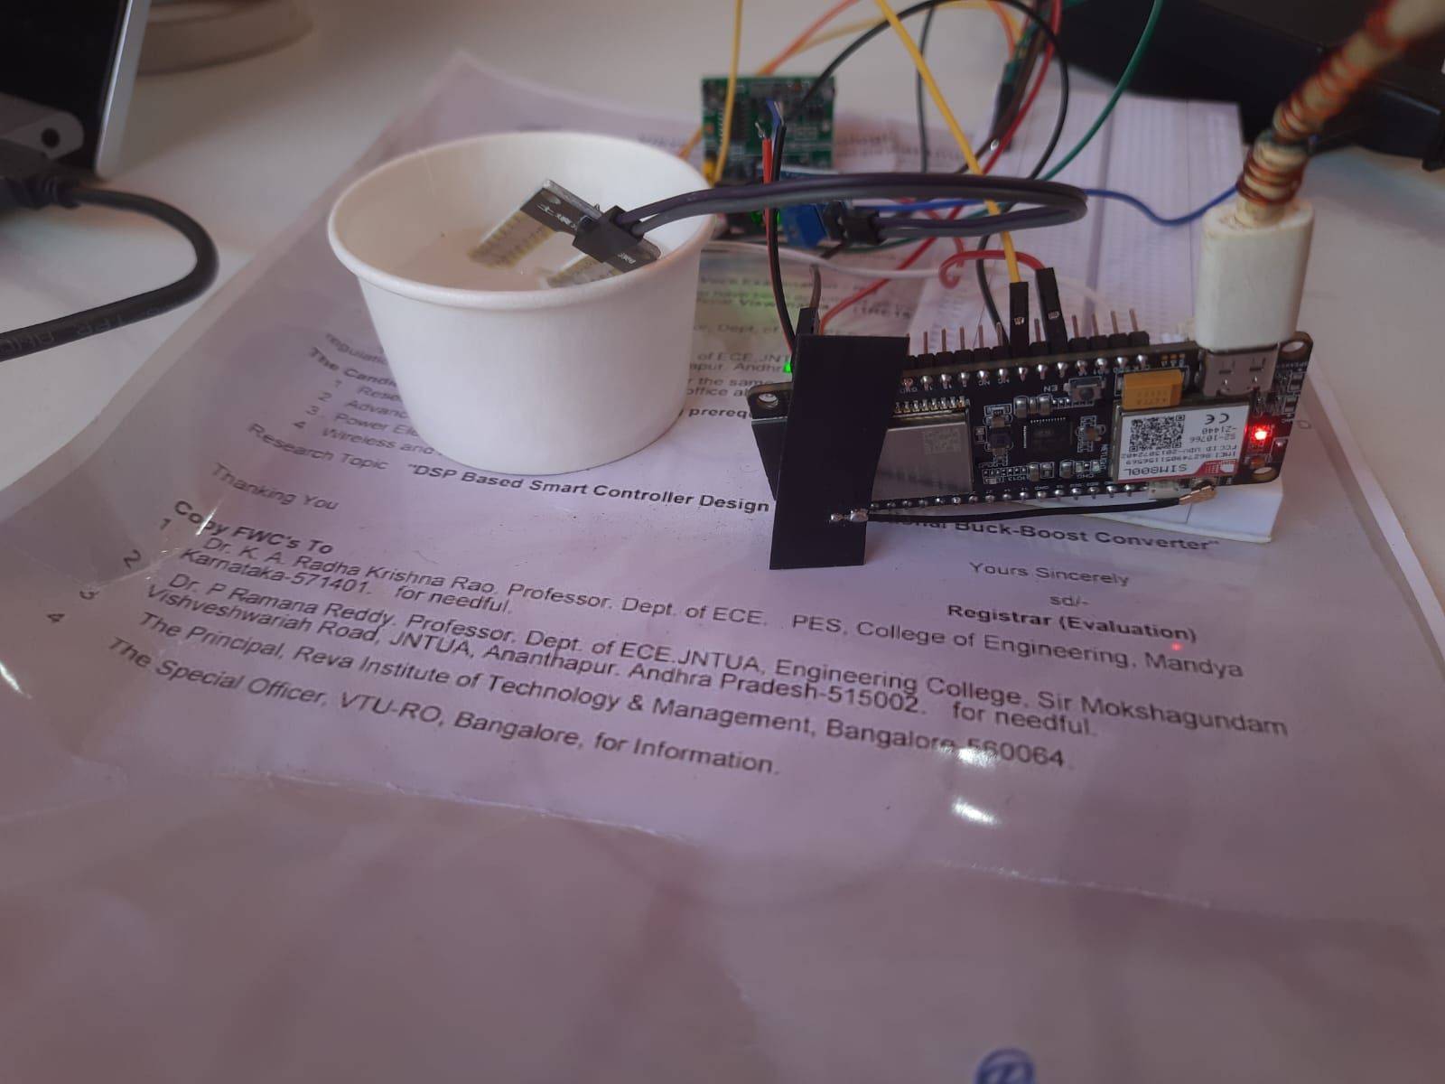

**Cold Chain Monitoring**

IoT (Internet of Things) Cold Chain Monitoring is a technology solution that leverages the power of IoT devices and sensors to monitor and manage the temperature and other environmental conditions of products as they move through the supply chain, especially in industries like food and pharmaceuticals where temperature control is critical. The "cold chain" refers to the uninterrupted temperature-controlled supply chain for perishable products, ensuring they remain within specified temperature ranges from production to consumption.

Here are the key components and aspects of IoT Cold Chain Monitoring:

1.Sensors and Devices: IoT sensors are placed at various points in the supply chain, such as storage facilities, transportation vehicles, and even individual product packages. These sensors can measure temperature, humidity, light exposure, and other relevant environmental factors.

2.Data Transmission: The data collected by sensors is transmitted in real-time or at regular intervals to a central server or cloud platform through wireless communication technologies like Wi-Fi, cellular networks, or LPWAN (Low-Power Wide-Area Network). This enables remote monitoring and management.

3.Data Analysis and Reporting: The collected data is analyzed to ensure that products are maintained within the specified temperature ranges. If any deviations are detected, alerts are generated for immediate corrective actions. Detailed reports and historical data are also available for compliance and quality assurance purposes.

4.GPS Tracking: In addition to temperature monitoring, many IoT Cold Chain Monitoring solutions incorporate GPS tracking to provide real-time location information for shipments. This helps in tracking the movement and expected arrival times of products.

5.Alerts and Notifications: Users receive alerts and notifications via email, SMS, or mobile apps in case of temperature fluctuations or other environmental anomalies. These alerts enable timely intervention to prevent spoilage or damage to the products.

6.Compliance and Regulations: IoT Cold Chain Monitoring helps organizations comply with industry-specific regulations and quality standards. For example, in the pharmaceutical industry, adherence to Good Distribution Practices (GDP) is essential.



7.Efficiency and Cost Savings: By ensuring optimal temperature conditions throughout the supply chain, IoT Cold Chain Monitoring helps reduce product spoilage, minimize losses, and improve overall operational efficiency. It also reduces the need for manual temperature checks and monitoring.

8.Integration: These systems can be integrated with existing supply chain management software and ERP (Enterprise Resource Planning) systems, providing a holistic view of the supply chain.

9.Scalability: IoT Cold Chain Monitoring solutions can be scaled to accommodate the needs of businesses of all sizes, from small local distributors to large multinational corporations.

10.Environmental Impact: Maintaining temperature control efficiently can reduce energy consumption and greenhouse gas emissions associated with cold chain operations, contributing to sustainability efforts.

GND’s Cold-Chain monitoring solution can help you efficiently manage the storage, shipping, and distribution of products that need a temperature-controlled environment, such as farm-fresh food or pharmaceuticals and other perishable that have specific temperature range requirements. Our solution provides managers with live data about temperature and location, mitigating any problems along the chain before they arise. We understand the careful live monitoring, sending and receiving of business-critical information is essential to success.

## Ensuring Quality And Safety Of Farm Fresh Perishable Goods With Real-Time Temperature Tracking

An intelligent cold chain system can track and ensure the quality of goods from manufacturer to end-user. However, cold chains are sensitive to electromechanical malfunctions, transit delays, theft, human error, and various other factors. With IoT cold chain monitoring systems, issues can be monitored in real-time, with a smart platform, and dashboards.  
Maintaining an optimal temperature during transportation of your food or pharmaceutical supplies is crucial in preventing costly spoilage. GND’s cold-chain monitoring solution provides a reliable and affordable way to ensure your coolers and freezers are working properly, potentially saving you dollars in unnecessary damage.

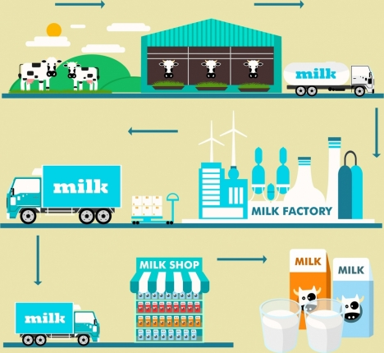

**Smart Cold Chain Benefits​**

Reduce Spoilage and Waste: Receive real-time alerts if a cooler’s temperature is outside of its nominal range.

Save Time and Resources: Automated system tracks temperatures for you, so no more manual checking.

Preventive Maintenance: Be aware of early warning signs that can help prevent more cooling failure.

Monitor from Anywhere: 24/7 access from anywhere via the dashboards.Maintain Regulatory Compliance: Tracking cooler temperatures can help you achieve and maintain regulatory

ComplianceProtect Brand Reputation: There is nothing more valuable than your Brand – make sure it protected.

Improved customer satisfaction on demand side.

Container Security, Efficiency, Manageability & Capacity on the supply side.

Reduces errors and time spent taking manual checks.Variety of alarm notifications from beacon, email & SMS.

**Smart Cold Chain Specifications**

Superior accuracy temp ±0.3°C, humidity ±2%

Wide measurement range -30°C to +60°C

Flexibility to add additional sensors including door events, CO2 & differential pressure

Wirelessly record up to 1 or 45 days.

Flexible offerings for cold-chain, warehouse applications

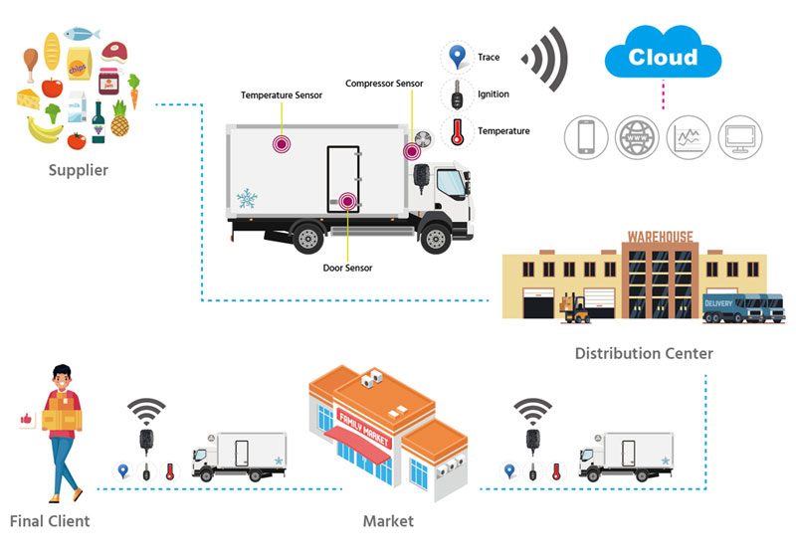

**IoT Cold Chain Monitoring Block Function**

**+---------------------------+**

**| Data Center |**

**| (Cloud Platform) |**

**+---------------------------+**

**|**

**|**

**+---------v----------+**

**| IoT Gateway |**

**| (Edge Processing) |**

**+---------|----------+**

**|**

**+---------v----------+**

**| Sensors |**

**| (Temperature, Humidity, |**

**| GPS, Shock, etc.) |**

**+---------|----------+**

**|**

**+---------v----------+**

**| Microcontroller |**

**| (Data Processing) |**

**+---------|----------+**

**|**

**+---------v----------+**

**| Communication |**

**| (Wi-Fi, Cellular, |**

**| LPWAN, etc.) |**

**+---------|----------+**

**|**

**+---------v----------+**

**| User Interface |**

**| (Dashboard, Alerts, |**

**| Reports, etc.) |**

**+-------------------+**

This block diagram represents a simplified version of an IoT cold chain monitoring system. In practice, there may be additional components, redundancy measures, and security features to ensure the reliable and secue monitoring of the cold chain.

1. **Data Center (Cloud Platform)**: This is where data from various sensors and gateways is collected, stored, and processed. Cloud platforms are commonly used for scalability and accessibility.
2. **IoT Gateway (Edge Processing)**: The IoT gateway acts as an intermediary between the sensors and the data center. It may perform initial data preprocessing, such as filtering or aggregation, before transmitting data to the cloud.
3. **Sensors**: These include temperature sensors, humidity sensors, GPS sensors, shock sensors, and any other sensors necessary to monitor the cold chain's conditions. They collect data from the environment.
4. **Microcontroller (Data Processing)**: Microcontrollers or embedded systems process data from sensors, control sensor operations, and may perform some local data analysis. They send the processed data to the IoT gateway.
5. **Communication**: Data collected by the microcontroller is transmitted to the IoT gateway via various communication methods, such as Wi-Fi, cellular networks, Low Power Wide Area Networks (LPWANs), or other suitable wireless protocols.
6. **User Interface**: This component provides a means for users to interact with the system. It includes a dashboard for real-time monitoring, alerts, notifications, and reporting tools.
7. In operation, sensors continuously collect data from the cold chain environment. This data is then processed by the microcontroller and transmitted to the IoT gateway. The gateway forwards the data to the cloud platform, where it is stored and analyzed. Users can access the data and system status through the user interface.

**Data Result over Blynk iot cloud**

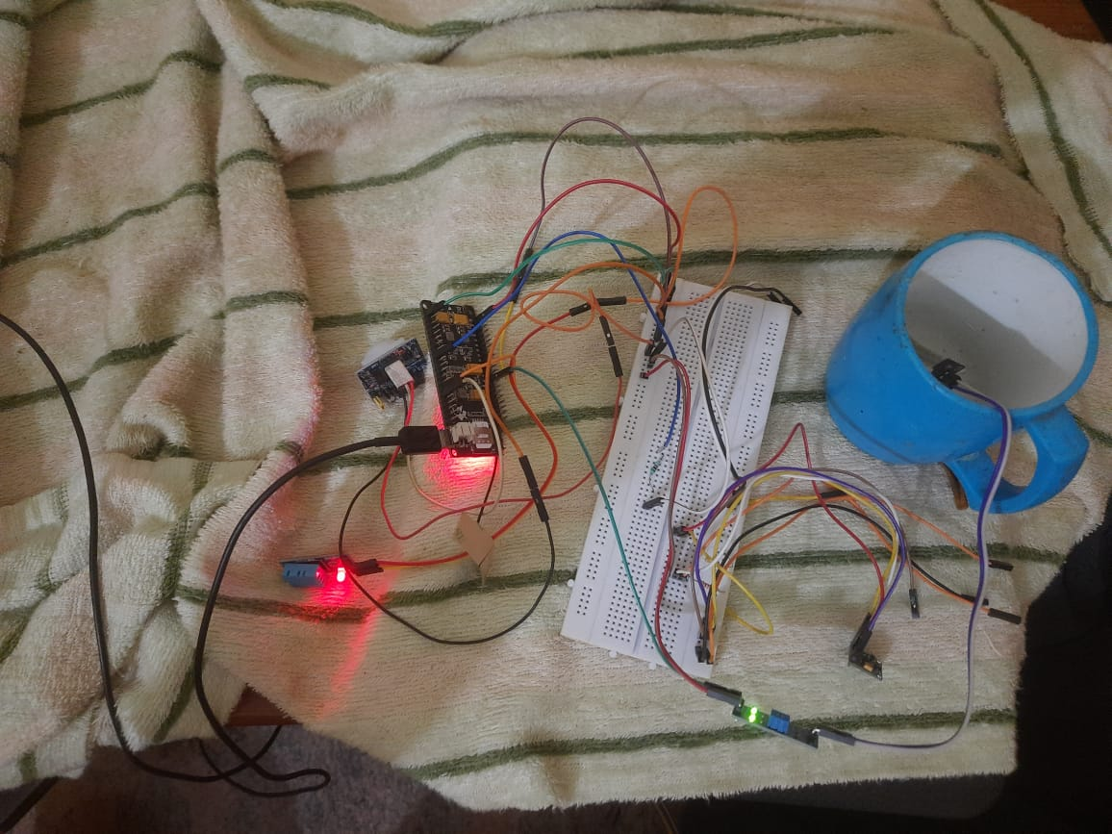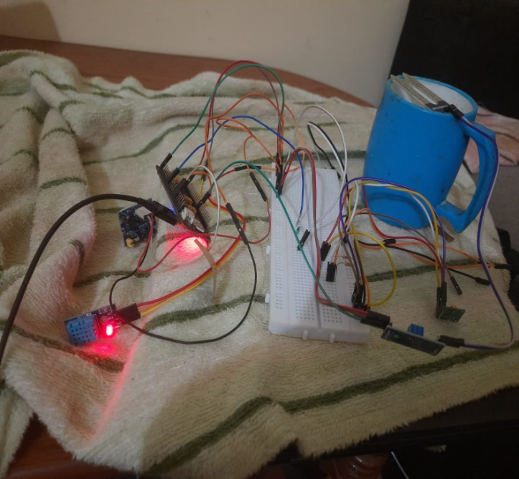Blynk IoT Cloud is a cloud-based platform designed for building and managing Internet of Things (IoT) projects and applications. It is part of the Blynk ecosystem, which includes a popular mobile app called Blynk that allows users to create custom IoT applications and control IoT devices from their smartphones.

**Blynk Digital Dashboard**

A Digital dashboard is a graphic interface that is created by selecting, dragging, and dropping widgets from the widget box. Every widget needs some energy to operate. When each Blynk account is created, a user will be receive 2,000 energy. The energy balance will decrease once a widget is used as the details in Figure 13 indicate. The 3 widgets used in the present research were as follows. Gauge widget for viewing real-time data. Super chart widget for viewing graphical data and comparing the humidity data in each period. Notification widget for sending an alert when abnormal data are detected or when the microcontroller cannot be contacted due to a power shortage.

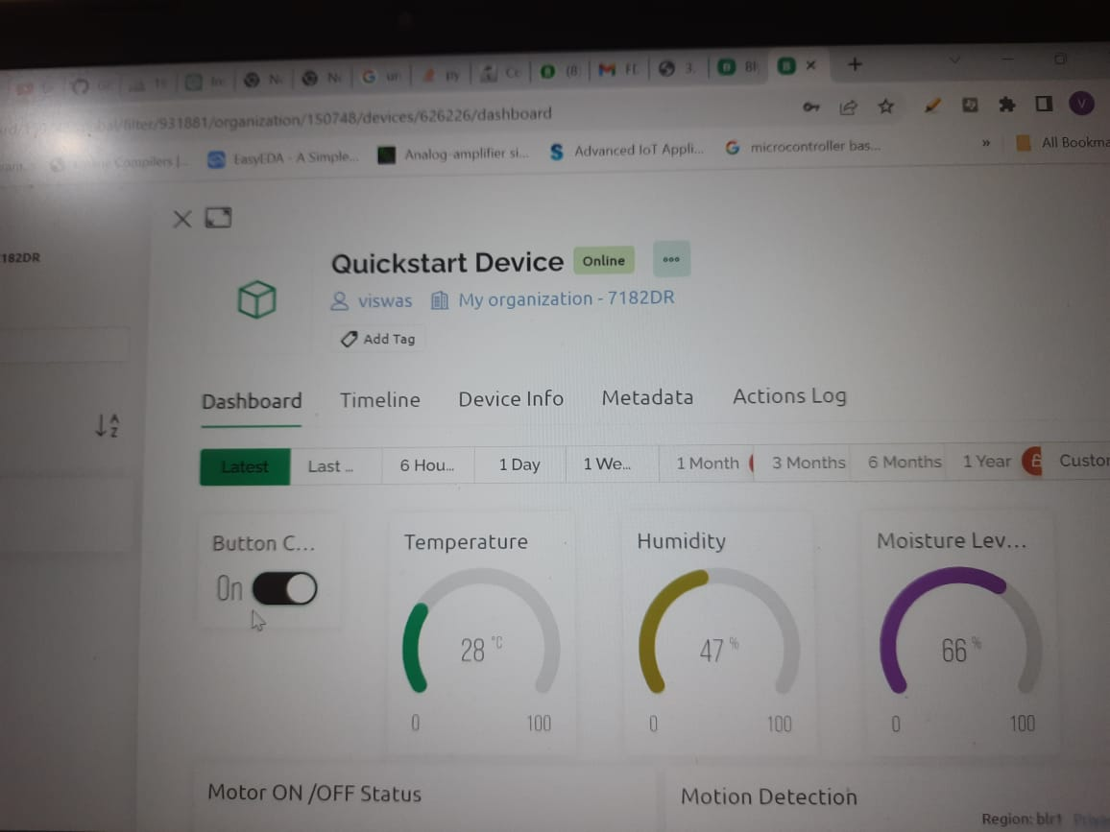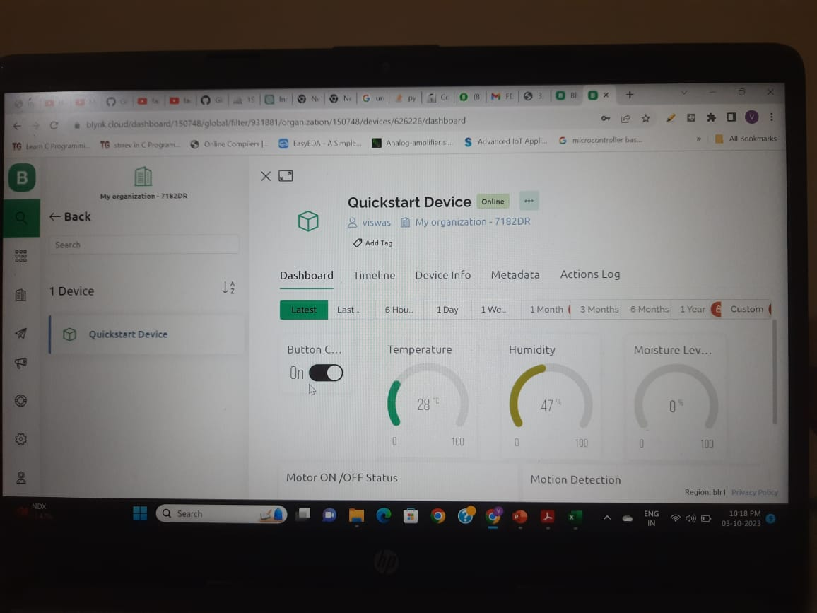

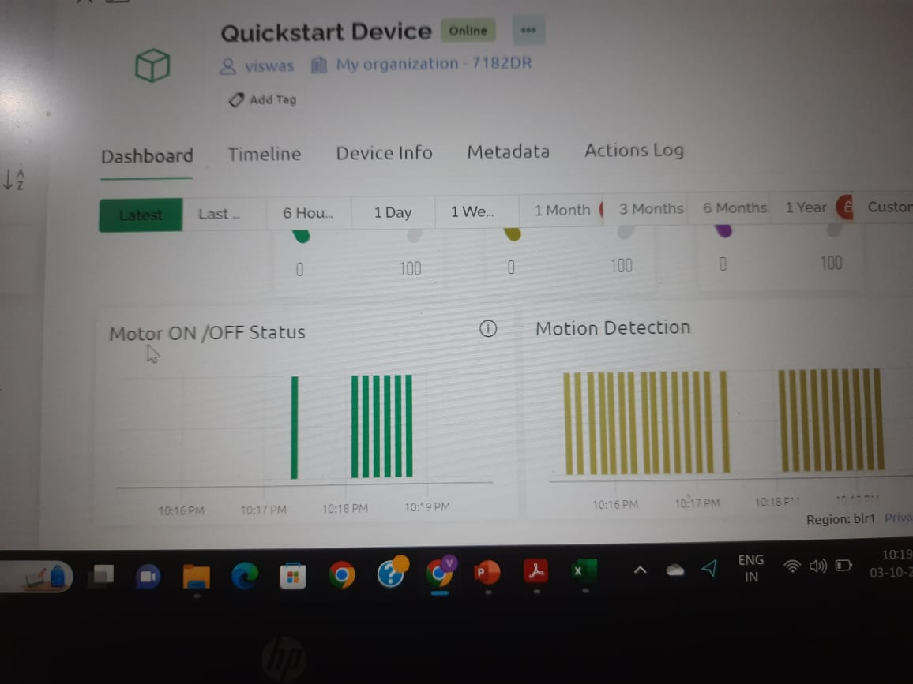As excessive humidity can negatively affect the, this experimental research used the IoT technology to measure and monitor its humidity. The developed real-time monitoring system can measure the humidity of paddy at any time, especially in inaccessible areas where many paddy bags are stacked on each other. The results of this research are described in greater detail as follows. A. Smart Farm Monitoring The humidity data can be displayed on a smartphone through the use of the Blynk mobile application. The digital dashboard was created to show the humidity data obtained from the smart capsules. The smart were able to measure and monitor the humidity of the paddy bags in the 4 storage locations within the warehouse. The gauge widget was used to display the data in real time, whereas the super chart widget was used to compare the humidity of paddy in the 4 different locations in form of graphical data. In this way, the responsible person could track and monitor the humidity of the paddy at any time and from any location.

**Blynk Notification**

A notification would be sent in case any device was disconnected from the system. Once there was an offline device, the Blynk application would send an alert message to the system administrator’s smartphone, as shown in Figure 20. The notification widget allowed the system administrator to set the format of the notification message and specify the target email addresses on his/her own. Thus, when a device was offline, the system administrator would be alerted and be able to solve the problem in time.

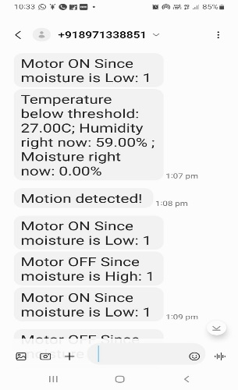 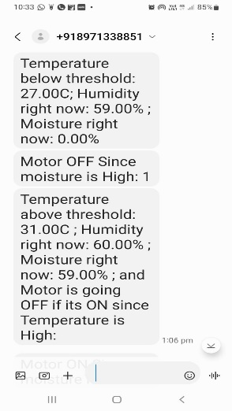

**Conclusion**

The future of IoT is virtually unlimited due to advances in technology and consumers ‘desire to integrate devices such as smartphones with household

machines. Wi-Fi has made it possible to connect people and machines on land, in the air, and at sea. The IoT has the potential to dramatically increase the availability of information, and is likely to transform companies and organizations in virtually every industry around the world. As such, finding ways to leverage the power of the IoT is expected to factor into the strategic objectives of most technology companies, regardless of their industry focus.

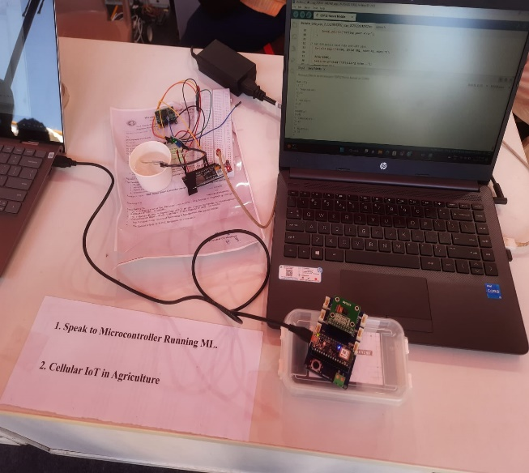

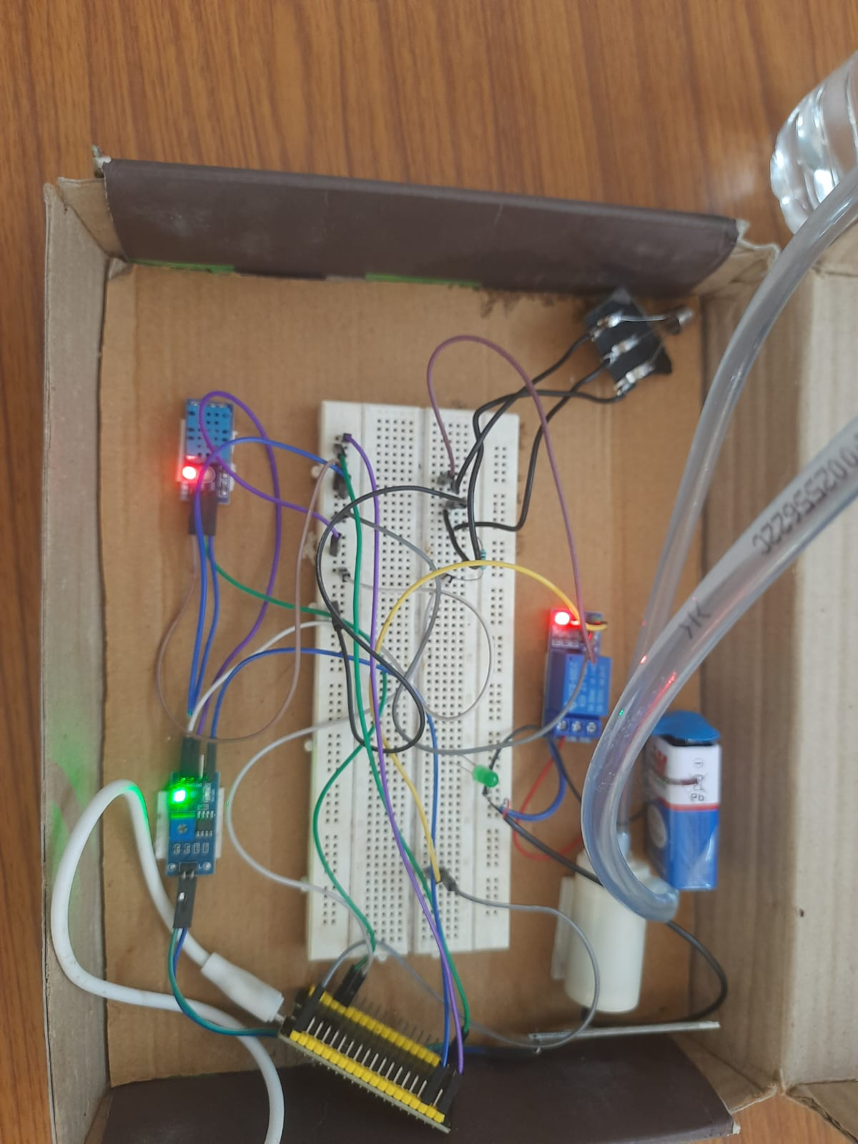

This internship helped us experiencing new, developing technology. Along with teaching us new things, it also taught us teamwork, which I believe is more important to grow as a human being.The present research focused on applying the IoT technology to monitor the humidity of paddy bags stored in a warehouse using smart capsules. According to the research results, the Blynk mobile application could work well on Android and iOS. Blynk users can use basic widgets for free. However, an additional payment is required in case they want to use a lot of widgets. In the present research, the researcher spent about 300 USD to create the hardware. The results suggested that the Blynk server could systematically store the humidity data sent by the sensor installed within each paddy bag. Moreover, the Blynk application was able to effectively display all of the related data, including the humidity sensed by each smart capsule, the status of each device, and the multipleline graph comparing the humidity data from the 4 smart capsules at each specific time, on a real-time basis. This indicated that the developed system was suitable for monitoring the humidity of paddy in order to prevent excessive humidity, which is the main cause of rotting

# References

### Websites

1. <http://www.beechamresearch.com/download.aspx?id=18>
2. <http://www.idc.com/getdoc.jsp?containerId=prUS25658015>
3. [https://www.abiresearch.com/press/the-internet-of-things-will-drive-](https://www.abiresearch.com/press/the-internet-of-things-will-drive-wireless-connect/) [wireless-connect/](https://www.abiresearch.com/press/the-internet-of-things-will-drive-wireless-connect/)
4. [https://www.abiresearch.com/press/the-internet-of-things-will-drive-](https://www.abiresearch.com/press/the-internet-of-things-will-drive-wireless-connect/) [wireless-connect/](https://www.abiresearch.com/press/the-internet-of-things-will-drive-wireless-connect/)
5. <http://grouper.ieee.org/groups/2413/>
6. [https://www.iotivity.org](https://www.iotivity.org/)
7. https://ieeexplore.ieee.org/document/8612441
8. [http://openinterconnect.org/oic-news-releases/open-interconnect-](http://openinterconnect.org/oic-news-releases/open-interconnect-consortium-forms-liaison-with-the-industrial-internet-consortium-to-accelerate-iot-standards/) [consortium-forms-liaison-with-the-industrial-internet-consortium-to-](http://openinterconnect.org/oic-news-releases/open-interconnect-consortium-forms-liaison-with-the-industrial-internet-consortium-to-accelerate-iot-standards/) [accelerate-iot-standards/](http://openinterconnect.org/oic-news-releases/open-interconnect-consortium-forms-liaison-with-the-industrial-internet-consortium-to-accelerate-iot-standards/)
9. <https://en.wikipedia.org/wiki/Internet_of_things> 10.<https://www.researchgate.net/publication>

11.https[://www.aca](http://www.academia.edu/)d[emia.e](http://www.academia.edu/)du

12. **https://gndsolutions.in/cold-chain-monitoring_iot/**